**UNIT-3**

Agility and Knowledge Management

**Part-A**

**Agility and Knowledge Management**

Agility and Knowledge Management are two interconnected concepts that are critical to the success of modern organizations. Together, they enable businesses to adapt quickly to changing environments, innovate, and maintain competitive advantage.

**Understanding Agility:**

**Agility** refers to an organization’s ability to rapidly adapt to market changes, customer demands, and technological advancements. It encompasses:

* **Flexibility**: Adjusting strategies, processes, and structures efficiently.
* **Speed**: Making timely decisions and implementing changes.
* **Responsiveness**: Anticipating and addressing emerging trends or issues.

Key features of agility include:

* Cross-functional collaboration.
* Iterative processes, such as those used in Agile software development.
* Emphasis on delivering value incrementally.

**Understanding Knowledge Management (KM)**

**Knowledge Management (KM)** involves creating, sharing, using, and managing an organization’s knowledge assets effectively. These assets include:

* **Explicit Knowledge**: Documented information, like manuals, policies, and procedures.
* **Tacit Knowledge**: Personal know-how and insights held by employees.

KM processes include:

1. **Knowledge Creation**: Generating new insights or ideas (e.g., through R&D, brainstorming).
2. **Knowledge Sharing**: Disseminating knowledge across teams or departments.
3. **Knowledge Storage and Retrieval**: Ensuring knowledge is accessible when needed.
4. **Knowledge Application**: Using knowledge to make decisions and solve problems.

**Applications of Agility and KM**

1. **Software Development**:
   * Agile methodologies like Scrum rely on KM tools (e.g., wikis, documentation) to ensure transparency and collaboration.
2. **Healthcare**:
   * Hospitals use KM to train staff and maintain best practices while adopting agile approaches to manage crises (e.g., during a pandemic).
3. **Manufacturing**:
   * Lean manufacturing leverages KM for continuous improvement and agility in production processes.
4. **Customer Service**:
   * KM systems provide customer service teams with real-time information, enabling swift resolution of customer issues.

**Challenges in Combining Agility and KM**

1. **Cultural Resistance**:
   * Employees may resist sharing knowledge or adopting agile practices.
2. **Technology Integration**:
   * Mismatched or outdated tools can hinder knowledge flow.
3. **Knowledge Silos**:
   * Departments may hoard information, reducing overall agility.
4. **Maintaining Relevance**:
   * Keeping knowledge updated in fast-changing environments can be challenging.

**6. Best Practices**

1. **Invest in Technology**:
   * Use KM platforms (e.g., SharePoint, Confluence) integrated with agile project management tools (e.g., Jira, Trello).
2. **Foster a Knowledge-Sharing Culture**:
   * Reward collaboration and transparency.
3. **Train Teams**:
   * Equip employees with skills in both agile methodologies and effective knowledge sharing.
4. **Implement Feedback Mechanisms**:
   * Encourage regular feedback to refine processes and update knowledge repositories.
5. **Monitor and Measure**:
   * Use metrics to assess KM effectiveness and its impact on agility (e.g., response times, innovation rates).

**7. Conclusion**

Agility and Knowledge Management are mutually reinforcing concepts that drive innovation, efficiency, and adaptability. Organizations that effectively integrate these practices can better navigate complex and rapidly evolving environments, ensuring sustained success in the face of uncertainty. By fostering a culture of collaboration and leveraging advanced tools, businesses can achieve the dual goals of agility and robust knowledge management.

**Agile information systems**

**Agile Information Systems (AIS)** refer to information systems (IS) designed and managed using Agile principles to enhance their adaptability, responsiveness, and alignment with evolving business needs. AIS supports businesses in responding to dynamic environments by enabling rapid and flexible changes in technology and processes.

**Key Characteristics of Agile Information Systems**

1. **Modularity**:
   * Systems are designed as modular components, allowing for easier updates and integration with other systems.
2. **Flexibility**:
   * AIS can quickly adapt to changes in business processes, regulations, or market demands.
3. **User-Centric Design**:
   * Emphasis on continuous feedback from end users to ensure systems meet actual needs.
4. **Iterative Development**:
   * Systems are developed and improved incrementally, delivering value in stages rather than waiting for a complete system rollout.
5. **Collaboration**:
   * Close cooperation between business stakeholders, IT teams, and end users to ensure alignment with goals.
6. **Scalability**:
   * AIS can scale up or down to meet organizational needs, ensuring they remain effective as businesses grow or change.

**Agile Principles in Information Systems Development**

1. **Customer Collaboration**:
   * Frequent interaction with users ensures that the system is aligned with business priorities and user requirements.
2. **Incremental Delivery**:
   * Functional parts of the system are delivered early and continuously refined based on feedback.
3. **Flexibility to Change**:
   * The system architecture and development process are designed to accommodate evolving requirements.
4. **Cross-Functional Teams**:
   * Teams consist of developers, testers, and business analysts working collaboratively.
5. **Short Development Cycles**:
   * Use of sprints or iterations for rapid progress and delivery.

**Components of Agile Information Systems**

1. **Agile Software Development**:
   * Development frameworks like Scrum, Kanban, or XP ensure continuous delivery of IS features.
2. **Cloud Computing**:
   * Cloud platforms provide scalable infrastructure, enabling faster deployment and adaptability.
3. **Microservices Architecture**:
   * Systems are broken into small, independent services that can be updated or replaced without affecting the entire system.
4. **Automation Tools**:
   * Tools for continuous integration, testing, and deployment to speed up development and reduce errors.
5. **Data-Driven Decision-Making**:
   * Agile IS supports real-time data collection and analysis to guide business decisions.

### ****Common Agile Methodologies for Information Systems****

**Scrum**: A popular agile framework that uses fixed-length sprints (usually 2-4 weeks) with roles like Scrum Master, Product Owner, and Development Team. Scrum focuses on continuous feedback, retrospectives, and collaboration.

**Kanban**: A more flexible, flow-based approach where work is visualized, and tasks are completed one at a time based on their priority. It focuses on continuous delivery and limiting work in progress (WIP).

**Extreme Programming (XP)**: Emphasizes technical excellence and continuous improvement with practices like pair programming, test-driven development (TDD), and frequent releases of small, working software modules.

**Lean Software Development**: Focuses on eliminating waste (e.g., unnecessary features or delays) and improving efficiency by delivering small, incremental value.

**Benefits of Agile Information Systems**

1. **Enhanced Responsiveness**:
   * Quickly adapt to changing business needs or market conditions.
2. **Improved Stakeholder Satisfaction**:
   * Regular delivery of features ensures users see value early in the process.
3. **Reduced Risk**:
   * Incremental development minimizes the likelihood of major project failures.
4. **Higher Quality**:
   * Continuous testing and user feedback ensure better system performance and usability.
5. **Cost Efficiency**:
   * Agile IS reduces waste by focusing on delivering only what is necessary and valuable.

**Examples of Agile Information Systems**

1. **Enterprise Resource Planning (ERP) Systems**:
   * Modular ERP systems that can adapt to organizational changes.
2. **Customer Relationship Management (CRM) Systems**:
   * Agile CRM platforms like Salesforce, which allow for customized workflows and iterative enhancements.
3. **E-Commerce Platforms**:
   * Agile development of features like payment systems, user interfaces, and inventory management.
4. **Business Intelligence (BI) Systems**:
   * Flexible analytics tools that adapt to changes in data sources and reporting needs.

**Challenges of Agile Information Systems**

1. **Cultural Resistance**:
   * Organizations may struggle to adopt Agile practices if accustomed to traditional methods.
2. **Complexity in Integration**:
   * Integrating Agile IS with legacy systems can be challenging.
3. **Scalability Issues**:
   * Scaling Agile practices across large organizations or systems may require additional frameworks like SAFe.
4. **Continuous Resource Demand**:
   * Agile systems require ongoing investment in development, maintenance, and user engagement.

Agile Information Systems are increasingly critical in environments where speed, adaptability, and user satisfaction are key competitive factors. By embracing Agile principles, organizations can create IS that drive innovation and efficiency.

**Agile Decision Making**

**Agile Decision Making** refers to a flexible, collaborative, and iterative approach to making decisions within organizations. It aligns with Agile principles by focusing on responsiveness to change, stakeholder involvement, and the continuous pursuit of value. This approach is particularly effective in fast-paced environments where decisions must adapt to new information and evolving priorities.

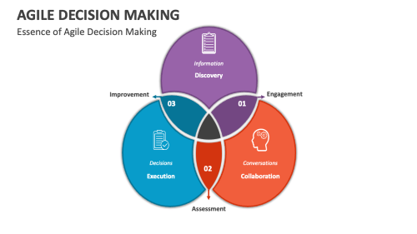

**Key Principles of Agile Decision Making**

1. **Decentralization**:
   * Empower teams or individuals closest to the issue to make decisions, reducing bottlenecks and enhancing responsiveness.
2. **Iterative Process**:
   * Decisions are revisited and refined as new information becomes available, following a "test, learn, and adapt" cycle.
3. **Collaboration**:
   * Involve cross-functional teams and stakeholders to ensure diverse perspectives and buy-in.
4. **Transparency**:
   * Share relevant data and rationale openly, ensuring that decisions are well-informed and understood.
5. **Focus on Value**:
   * Prioritize decisions that deliver the most value to customers or the organization.
6. **Speed and Simplicity**:
   * Strive for decisions that are timely and avoid over-analysis or unnecessary complexity ("good enough for now" mindset).

**Steps in Agile Decision Making**

## Define the problem and the goal

The first step in agile decision making is to clearly define the problem you are trying to solve and the goal you are aiming for. This will help you narrow down the scope of your decision, identify the relevant criteria and constraints, and communicate your expectations to others. You can use tools such as problem statements, SMART goals, or OKRs (objectives and key results) to frame your problem and goal in a concise and measurable way.

## Gather and analyze data

The next step is to gather and analyze data that will inform your decision. Data can come from various sources, such as market research, customer feedback, analytics, experiments, or experts. You need to evaluate the quality, relevance, and reliability of your data, and avoid biases, assumptions, or gaps in your analysis. You can use tools such as SWOT analysis, PESTLE analysis, or decision matrices to organize and compare your data and identify the pros and cons of different options.

## Generate and test alternatives

The third step is to generate and test alternatives that could potentially solve your problem and achieve your goal. You need to be creative and open-minded, and consider a range of possibilities, not just the obvious or familiar ones. You also need to be realistic and pragmatic, and test your alternatives against your criteria and constraints, as well as the feedback and input of your stakeholders. You can use tools such as brainstorming, prototyping, or A/B testing to generate and test alternatives and learn from the results.

## Choose and implement the best option

The fourth step is to choose and implement the best option based on your data, analysis, and testing. You need to be decisive and confident, and justify your choice with evidence and logic. You also need to be transparent and collaborative, and communicate your decision clearly and effectively to your stakeholders, and address any concerns or objections they may have. You can use tools such as RACI matrix, stakeholder map, or action plan to assign roles and responsibilities, and monitor and manage the implementation process.

## Evaluate and iterate the outcome

The final step is to evaluate and iterate the outcome of your decision, and measure its impact and performance against your goal. You need to be honest and objective, and collect and analyze feedback and data from your stakeholders, customers, and the market. You also need to be flexible and responsive, and make adjustments and improvements based on your learning and insights. You can use tools such as KPIs (key performance indicators), surveys, or retrospectives to evaluate and iterate the outcome and celebrate your successes and learnings.

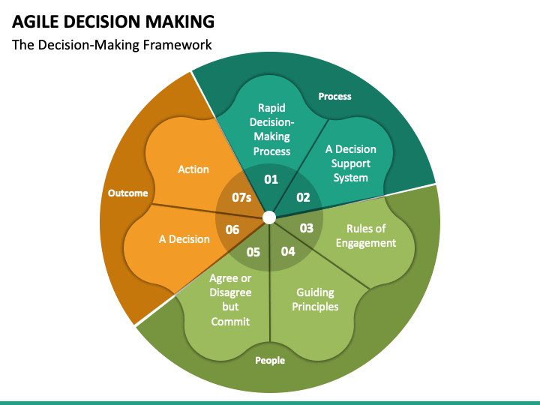

**Techniques for Agile Decision Making**

1. **Lean Coffee**:
   * An informal meeting structure where participants prioritize topics for discussion in real-time, ensuring focus on the most important issues.

**2.Prioritization Matrix (Eisenhower Matrix)**

* **Purpose**: To help teams make decisions about which tasks or features to focus on by categorizing them based on urgency and importance.
* **How it Works**: Features, tasks, or issues are plotted into four quadrants:
  + **Urgent and Important**
  + **Not Urgent but Important**
  + **Urgent but Not Important**
  + **Not Urgent and Not Important**
* **When to Use**: When deciding which features or tasks should be prioritized for the next sprint or iteration.

**3.MoSCoW Method**

* **Purpose**: To prioritize features, tasks, or requirements based on their importance and urgency.
* **How it Works**: Items are classified into four categories:
  + **Must Have**: Non-negotiable requirements.
  + **Should Have**: Important but not critical.
  + **Could Have**: Nice to have but not essential.
  + **Won’t Have**: Items that are out of scope for the current project.
* **When to Use**: To help prioritize backlog items, features, or user stories.

**4.SWOT Analysis**

* **Purpose**: To assess the strengths, weaknesses, opportunities, and threats related to a particular decision or project.
* **How it Works**: A team analyzes internal strengths and weaknesses and external opportunities and threats. This helps in identifying potential risks and benefits and making more informed decisions.
* **When to Use**: When evaluating options or making strategic decisions.

**5.Delphi Technique**

* **Purpose**: To reach a consensus on decisions through multiple rounds of anonymous feedback from a panel of experts.
* **How it Works**: Experts provide their opinions or estimates in several rounds, with feedback provided between rounds. The process continues until the group reaches consensus.
* **When to Use**: When making complex decisions requiring expert input or in situations where a decision needs to be made with minimal bias.

**Benefits of Agile Decision Making**

1. **Increased Responsiveness**:
   * Faster decisions enable organizations to adapt to changes quickly.
2. **Empowered Teams**:
   * Decentralization fosters accountability and ownership among team members.
3. **Improved Outcomes**:
   * Collaborative and data-driven decisions lead to better solutions.
4. **Reduced Risk**:
   * Iterative reviews ensure decisions remain relevant and aligned with goals.
5. **Higher Stakeholder Satisfaction**:
   * Transparent and inclusive processes build trust and confidence.

**Challenges in Agile Decision Making**

1. **Information Overload**:
   * Teams may struggle to process large volumes of data in a timely manner.
2. **Conflicting Priorities**:
   * Aligning diverse stakeholder interests can complicate the decision-making process.
3. **Resistance to Change**:
   * Traditional hierarchical structures may resist decentralized decision-making.
4. **Analysis Paralysis**:
   * Balancing speed with thoroughness can be challenging.
5. **Cultural Adaptation**:
   * Organizations must embrace a culture of trust, experimentation, and learning.

**Applications of Agile Decision Making**

* **Product Development**: Prioritizing features based on customer value and market trends.
* **Project Management**: Adjusting timelines and deliverables dynamically in response to risks or changes.
* **Operations**: Streamlining workflows and adapting processes to improve efficiency.
* **Leadership**: Strategic pivoting based on competitive or technological shifts.

Agile decision making ensures that organizations remain flexible and proactive, fostering resilience in dynamic environments.

**Earl's Schools of Knowledge Management**

The **Earl's Schools of Knowledge Management (KM)** framework, proposed by Michael Earl in 2001, categorizes different approaches to Knowledge Management based on how organizations manage and utilize knowledge. Earl identified seven "schools," grouped into three main categories, each reflecting distinct philosophies, strategies, and tools for managing knowledge within an organization.

### ****The Three Broad Categories and Seven Schools****

#### 1. ****Technocratic Schools****

Focus on leveraging technology to capture, store, and distribute knowledge.

**a. Systems School**:

* Emphasizes building IT systems to codify and share knowledge.
* Includes knowledge repositories, databases, and intranets.
* Suitable for organizations where explicit knowledge is key.
* Example: Enterprise Content Management (ECM) systems.

**b. Cartographic School**:

* Focuses on creating knowledge maps to locate and access expertise and information within the organization.
* Maps help identify knowledge holders, resources, and connections.
* Example: Expertise directories or skill maps.

**c. Engineering School**:

* Centers on designing workflows and processes to manage knowledge effectively.
* Often uses process automation and optimization.
* Example: Business Process Management (BPM) systems.

#### 2. ****Economic Schools****

Focus on leveraging knowledge to create tangible business value.

**d. Commercial School**:

* Treats knowledge as a commodity that can be monetized.
* Focuses on intellectual property, licensing, and knowledge-based services.
* Example: Consulting firms or companies selling proprietary research.

#### 3. ****Behavioral Schools****

Emphasize people, culture, and social interaction as key to managing knowledge.

**e. Organizational School**:

* Focuses on creating a culture and structure that facilitates knowledge sharing.
* Includes cross-functional teams, communities of practice, and collaborative environments.
* Example: Internal innovation hubs or collaborative platforms.

**f. Spatial School**:

* Emphasizes designing physical or virtual spaces that promote knowledge sharing and collaboration.
* Includes open office layouts, co-working spaces, and virtual collaboration tools.
* Example: Knowledge cafés or team-building workshops.

**g. Strategic School**:

* Aligns knowledge management with the organization's strategic goals.
* Focuses on embedding KM into long-term objectives and competitive strategies.
* Example: Corporate strategy programs that leverage organizational knowledge for innovation.

### ****Earl's Framework in Practice****

* Earl's schools help organizations identify their current KM approach and explore alternatives.
* Many organizations adopt a **hybrid model**, combining schools (e.g., using IT systems alongside fostering a collaborative culture).

### ****Benefits of Earl's Schools of KM****

* Provides a clear framework to categorize and assess KM practices.
* Encourages organizations to align KM initiatives with their unique needs and goals.
* Highlights the importance of balancing technology, people, and strategy in managing knowledge.

Earl’s framework is a valuable tool for organizations to design and refine their KM strategies, ensuring they maximize the value of their knowledge assets.

**Institutional Knowledge Evolution Cycle**

**What is Institutional Knowledge?**

Institutional knowledge is the collective knowledge and experience of an organization. Institutional knowledge isn’t just about knowing what works. It’s about working together to solve problems, and why things are done a certain way.

When referring to institutional knowledge, it’s all the information that exists within an organization. It includes everything from the best practices and processes of the company to the history of the products they sell.

The goal of institutional knowledge management is to create a shared understanding so that information sharing becomes part of the culture of a company.

**Types of Institutional Knowledge:**

There are three main types of institutional knowledge: tacit, explicit, and implicit.

1. **Tacit knowledge**

This refers to the skills, abilities, and expertise people have developed over time through experience. These include the ways in which people think, communicate, collaborate, and problem-solve. Tacit knowledge is the kind of knowledge that comes naturally to people who have been doing something for years. Tacit knowledge can be passed on through mentoring relationships, informal training programs, and formal education.

2. **Explicit knowledge**

This is the kind of information that can be taught. It’s usually written somewhere and available to anyone who needs it. Explicit knowledge is often referred to as “knowledge-based” or “formalized.” It’s defined by its accessibility. Explicit knowledge is easy to find and share. It includes written documents, spreadsheets, presentations, videos, and other forms of documentation.

**3. Implicit knowledge**

This is the type of knowledge that doesn’t exist anywhere else but inside the minds of those who know it. Implicit knowledge is the type of knowledge that doesn’t exist in a tangible form. Implicit knowledge is the kind of information people need to do their jobs well. It includes skills, attitudes, and behaviors that are learned through observation and practice.

Knowing these three main types of institutional knowledge will help you better understand why knowledge sharing is so important.

**The Importance of Institutional Knowledge**

There are many reasons why institutional knowledge should be considered a key element of any successful organization.

**1. Creates an internal network of experts**

Institutional knowledge is a valuable asset that can be leveraged across departments and functions. When employees learn from each other, it streamlines operations and ensures expertise is shared throughout the company**.**

**2. Makes your company more competitive**

By leveraging institutional knowledge, you gain a competitive advantage. You become more efficient and agile. Employees are able to solve problems faster and more accurately.

**3. Increases employee engagement**

Employees who feel valued and appreciated are more motivated to contribute and are more likely to stay at their job longer. When they’re happy, they perform better. They’re also more engaged when they see others benefiting from their contributions.

**4. Improves customer service**

Customers expect high-quality products and services. If employees aren’t knowledgeable about their company, they won’t be able to respond to customer queries or solve problems efficiently. By providing excellent customer service, you demonstrate your commitment to excellence.

**5. Reduces risk**

If you fail to leverage institutional knowledge, you run the risk of losing customers, clients, and partners. By investing in training and developing new talent, you’ll ensure your company has the right people on board.

**6. Promotes innovation**

People are generally more creative when they’re working in a team. An institutional knowledge base provides employees with what they need to collaborate and be creative. Collaboration breeds creativity. When teams openly share information, they create opportunities for collaboration and innovation.

**7. Builds trust**

Having institutional knowledge builds trust because it demonstrates transparency. People know what to expect from you and they have confidence that you’re doing everything you can to help them succeed. When employees have confidence in one another, they’re less likely to question authority. Trust builds loyalty. Loyalty leads to higher levels of productivity and efficiency.

**8. Keeps your staff productive**

Knowledge sharing helps employees focus on their tasks instead of searching for answers. When employees are confident they can rely on one another, they’re less distracted and more focused on completing their assignments.

The importance of institutional knowledge cannot be overstated. It’s one of the best ways to help your company stay relevant and continue to progress as things change.

**Institutional Knowledge Evolution Cycle**

The **Institutional Knowledge Evolution Cycle** describes the process through which an organization generates, captures, shares, utilizes, and updates its collective knowledge over time. This cycle ensures that knowledge remains relevant, accessible, and effectively applied to meet evolving organizational needs.

The institutional knowledge evolution cycle refers to the process through which an organization's knowledge and expertise develop and change over time. This cycle typically involves several key stages:

* **Creation**: Knowledge is initially created through research, experience, or innovation within the organization.
* **Capture**: The organization captures this knowledge through documentation, databases, or other knowledge management systems.
* **Sharing**: Knowledge is shared among employees through training, meetings, or collaborative platforms to ensure it is widely accessible.
* **Application**: Employees apply this knowledge in their work, leading to practical experience and further refinement.
* **Feedback**: As knowledge is applied, feedback is gathered, leading to updates, improvements, or corrections to the existing knowledge base.
* **Retention**: The refined knowledge is retained within the organization, ensuring that it is not lost when employees leave or circumstances change.
* **Adaptation**: Over time, the knowledge evolves to adapt to new technologies, market conditions, or organizational changes.

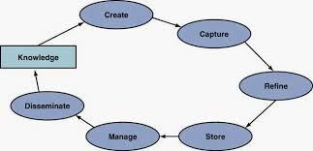

This cycle is continuous, with knowledge constantly being created, refined, and adapted to meet the evolving needs of the organization.

**Institutional knowledge evolution cycle - development, acquisition, refinement, distribution, deployment.**

* The **Institutional Knowledge Evolution Cycle** refers to the continuous process through which knowledge within an organization is developed, acquired, refined, distributed, and deployed over time. This cycle helps institutions retain and enhance their knowledge base, ensuring that valuable information is shared and applied effectively within the organization.

1. **Development**: Create new knowledge internally or through research.
2. **Acquisition**: Gather knowledge from external sources and integrate it into the organization.
3. **Refinement**: Improve and optimize knowledge for accuracy and relevance.
4. **Distribution**: Share knowledge across the organization to ensure accessibility.
5. **Deployment**: Implement knowledge in real-world scenarios to drive impact and organizational success.

# MODELS OF KM CYCLE

Knowledge management cycle is a process of transforming information into knowledge within an organization. It explains how knowledge is captured, processed, and distributed in an organization. In this chapter, we will discuss the prominent models of knowledge management cycle.

Till date, four models have been selected based on their ability to meet the growing demands. The four models are the Zack, from Meyer and Zack (1996), the Bukowitz and Williams (2000), the McElroy (2003), and the Wiig (1993) KM cycles.

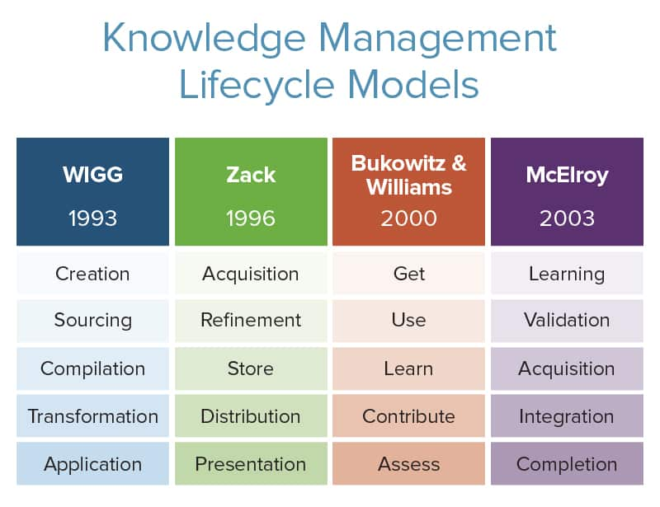

|  |  |  |  |  |
| --- | --- | --- | --- | --- |
|  |  |  |  |  |
|  |  |  |  |  |
|  |  |  |  |  |
|  |  |  |  |  |
|  |  |  |  |  |
|  |  |  |  |  |

## ZACK KNOWLEDGE MANAGEMENT MODEL:

The Zack model is extracted from work on the design and development of information products. In Meyer and Zack’s approach, the network between each stage is designed to be logical and standardized.

In this cycle, the major developmental stages of a knowledge repository are analyzed and mapped to the stages of a KM cycle.

The stages are acquisition, refinement, storage/retrieval, distribution, and presentation/use. This cycle is also known as the “reﬁnery.”

### Acquisition of Data or Information

Acquisition deals with issues regarding origin of raw materials such as scope, breadth, depth, credibility, accuracy, timeliness, relevance, cost, control, and exclusivity.

The guiding principle is the well- known proverb of “garbage in, garbage out.” That is, highest quality source data is required, else the intellectual products produced downstream will be lower.

### Refinement

Refinement may be physical (like migrating from one medium to another) or logical (like restructuring, relabeling, indexing, and integrating.)

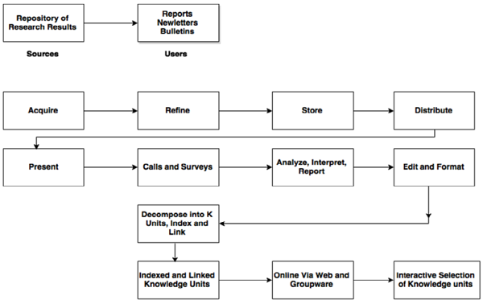

Refining also defines cleaning up (like sanitizing content so as to ensure complete anonymity of sources and key players involved) or standardizing (like conforming to templates of a best practice or lessons learned as used within that particular organization).

This stage also adds up to the value by creating more readily usable knowledge objects and by storing the content more ﬂexibly for future use.

### Storage / Retrieval

Storage or Retrieval forms a bridge between the upstream addition and refinement stages that feed the repository and downstream stages of product generation. Storage can be physical (file folders, printed information) as well as digital (database, knowledge management software).

### Distribution

Distribution defines how the product is to be delivered to the end-user (like fax, print, email) and encloses not only the medium of delivery but also its timing, frequency, form, language, and so on.

### Presentation

Context plays an important role in Presentation or Application stage. The performance of each of the preceding value-added steps is evaluated here – for example, does the user have enough context to be able to make use of this content? If not, the KM cycle has failed to deliver value to the individual and ultimately to the company.

The repository and the “refinery” combined enable the management of valuable knowledge of a firm. In this cycle, there is also an impression of having to continually renew the repository and the refinery in order to avoid elimination.

The Meyer and Zack model is one of the most complete picture of the key elements engaged in the knowledge management model. To be specific the notion of refinement is a crucial stage in the KM cycle and one that is often neglected.

## BUKOWITZ & WILLIAMS MODEL

Bukowitz and Williams portray a knowledge management process framework that outlines “how organizations generate, maintain and expand a strategically correct stock of knowledge to create value”.

In this framework, knowledge includes knowledge repositories, relationships, information technologies, communications infrastructure, functional skill sets, process know-how, environmental responsiveness, organizational intelligence, and external sources.

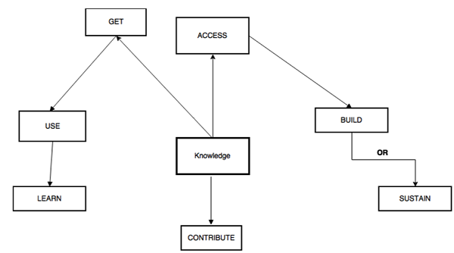

These stages aim on more long-range processes of matching intellectual capital to strategic needs.

* **Get Stage** is the first stage, it consists of seeking out information required in order to make decisions, solve problems, or innovate.
* **Use Stage** is the next stage, and it deals with how to combine information in new and interesting ways in order to foster organizational innovation. The spotlight is primarily on individuals and then on groups.
* **The Learn Stage** points to the formal process of learning from experiences as a means of creating competitive gain. Learning in enterprises is important because it serves the transition step between the application of ideas and the generation of new ones.
* **The Contribute Stage** of the Knowledge Management cycle deals with encouraging employees to post what they have learnt to the communal knowledge base (like a repository). Only in this way, can individual knowledge be made visible and available to the entire organization, where and when appropriate.

## MCELROY MODEL

McElroy outlines a knowledge life cycle that consists of the processes of knowledge production and knowledge integration, with a series of feedback loops to organizational memory, beliefs, and claims and the business-processing environment.

* Problem claim formulation is an attempt to learn and state the specific nature of the detected knowledge gap.
* Knowledge claim formulation acts as a response to approved problem claims via information acquisition and individual and group learning.
* New knowledge claims are tested and examined through knowledge claim evaluation processes.
* Evaluation of knowledge claims results in surviving knowledge claims that will be integrated as new organizational knowledge or falsified/undecided knowledge claims.

Experience gained from the application of knowledge in the organizational knowledge base leads to new claims and resulting beliefs, triggering the cycle to begin all over again.

In knowledge production, the primary processes are individual and group learning. Knowledge claim formulation, information acquisition; codified knowledge claim and knowledge claim evaluation.

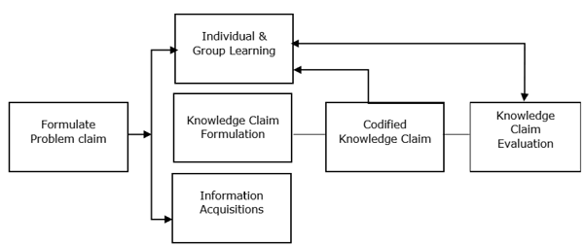

These knowledge production processes can be briefed as −

* Individual and group learning marks the first step in organizational learning.
* Knowledge claim validation includes codiﬁcation at an organizational level.
* A formalized procedure is essential for the receipt and codiﬁcation of individual and group innovations.
* Information addition is the process by which an organization deliberately or serendipitously acquires knowledge claims or information produced by others, usually external to the company. This stage plays a basic role in formulating new knowledge claims at the organizational level.

Knowledge integration is the process by which an organization announces new knowledge claims to its operating environment and retires old ones. It includes all knowledge transmission such as teaching, knowledge sharing, and other social activities that either connects an understanding of previously produced organizational knowledge to knowledge workers or accommodate newly minted knowledge.

One of the advantages of the McElroy cycle is the clear description of how knowledge is examined and a conscious decision is made as to whether or not it will be included into the organizational memory. The authorization of knowledge is a step that clearly differentiates knowledge management from document management. The KM cycle aims at processes to identify knowledge content that is of value to the organization and its employees

## WIIG MODEL

WIIG highlights the three conditions that need to be present for an organization to conduct its business successfully.

* It must have a business (commodities/services) and customers.
* It must have resources (people, budget, and facilities).
* It must have the strength to act.

WIIG marks the major purpose of KM as an effort “to make the organization intelligent-acting by facilitating the creation, accumulation, deployment and use of quality knowledge.” WIIG’s KM cycle shows how knowledge is built and used as individuals or as organizations.

The following figure shows the four major steps of the WIIG model.

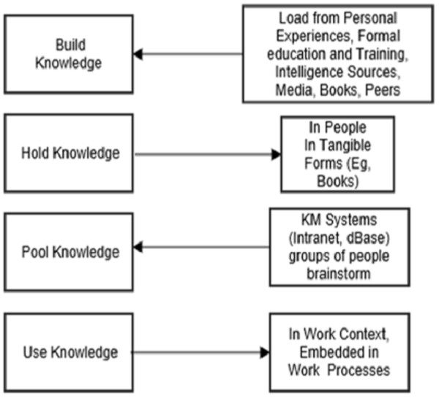

* **Building knowledge** − From external and internal knowledge sources
* **Holding knowledge** − Storing the information in a particular form
* **Pooling knowledge** − Through intranets and knowledge management portals
* **Applying knowledge** − In the context of work embedded in process